

TREE PLANTING GRANT SCHEME 2025
Closing Date: Sunday 28th September

Wicklow County Council’s annual tree grant is now open for applications until Sunday 28th September. The grant is open to Tidy Towns groups, resident associations, schools and other community groups. It is a grant to allow for tree, mixed native hedge and fruit tree planting in public spaces in their community. The grant aims to increase tree cover in our towns, compliment the All Ireland Pollinator Plan and support community gardening.

Name of group/organisation:________________________________________________

Contact Name: ___________________________________________________

Email: __________________________________________________________

Ph: ____________________________________________________________

Address: _______________________________________________________

If successful, we will need to set the group up on our finance system (For due diligence we will need to confirm account details if you have received grants/awards from us in the past). We would be obliged if you can provide the following at this stage:

Treasurer’s Name: _______________________________________________

Treasurer’s Email: ________________________________________________

Please list below details of trees you wish to purchase. A detailed quote from a garden centre/nursery will also be accepted.

Type of Tree  Species/Cultivar | Listed for biodiversity  or value Yes /No | No of Trees | Price per  Tree | Total  Price
Other Materials |  |  |  | Price
Total Price

Please comment on the suitability of trees selected for planting considering site space with relation to trees, proximity to built infrastructure, the eventual height and spread of trees and long term maintenance of the trees. Please use extra pages if needed.

How to Apply and Conditions for The Grant:

- Maximum grant payable may be up to 95% of the cost and is payable when the work is completed.
- Maximum grant available is €500. Reckonable expenditure would include the cost of the trees, ties and stakes but does not include the cost of labour for the planting.
- A written estimate of the cost from your supplier itemising the type of trees etc. will have to be submitted in order to determine the amount of grant to be allocated. Supplier must be a garden centre or nursery.
- The completed application form should be accompanied by a sketch/map showing the location of the proposed planting(s). We may need to get more information from you. (please see notes below)
- Please include how you intend to stake and insure best practice establishment ie control of grasses/vegetation/mulching/regular tree tie checks/watering in dry spells/community engagement
- Applications will be assessed on whether trees selected are suitable on proposed sites
- The relevant municipal district and other internal experts will be consulted to ensure that the trees are both appropriate to the site and broader tree schemes for the community or town.
- Trees must be planted on public sites.
- Site visits will be conducted as part of the grant process
- Receipts will be required as a condition of Wicklow County Council reimbursing the cost (ie 95%).
- The grant is for the planting of trees &hedgerows. It is not for shrubs or flowers.
- Native trees beneficial for pollinators and biodiversity will be considered for grant aid except in urban/sub-urban areas where non-natives will be considered. Please indicate if the proposed area is within a Special Area for Conservation.
- Fruit trees are acceptable for grant aid. Please indicate root stock.
- Applications that favour less mature trees (ie half standard/standards) rather than expensive heavy standards & semi mature will be given preference in funding. (Please provide these details from your supplier)
- A photo would be appreciated to show either the group planting or when the work is completed.
- We would strongly encourage applicants to attend our Winter tree planting and care webinars and our tree/fruit tree care workshops held in early Spring. Please indicate if you have attended any or similar in 2025 in your application. □
- This grant is not open to individuals or businesses.

Applications should be addressed to: Environmental Awareness Office
Wicklow County Council
County Buildings
Wicklow
eao@wicklowcoco.ie

Have you included?
Details | Yes/No
Sketch map of location of proposed planting
Written estimate / detailed quote from nursery / garden centre
Planting, staking and maintenance plan
All contact details including treasurer if different

For further information please contact Environmental Awareness Office by email eao@wicklowcoco.ie.

Note Applications close Sunday 28th September 2025
Successful applicants will be notified at the end of October 2024. All trees should be planted during before December where possible.

Notes on sketch maps/screen grabs for location purposes

Screen grabs indicating general areas for tree planting are useful but we need more specific details on locations in relation to other trees, utilities, footpaths, houses etc. We do not need professional drawings. The more information you can supply especially if you plan to plant in several areas or a large number.

The following are useful:
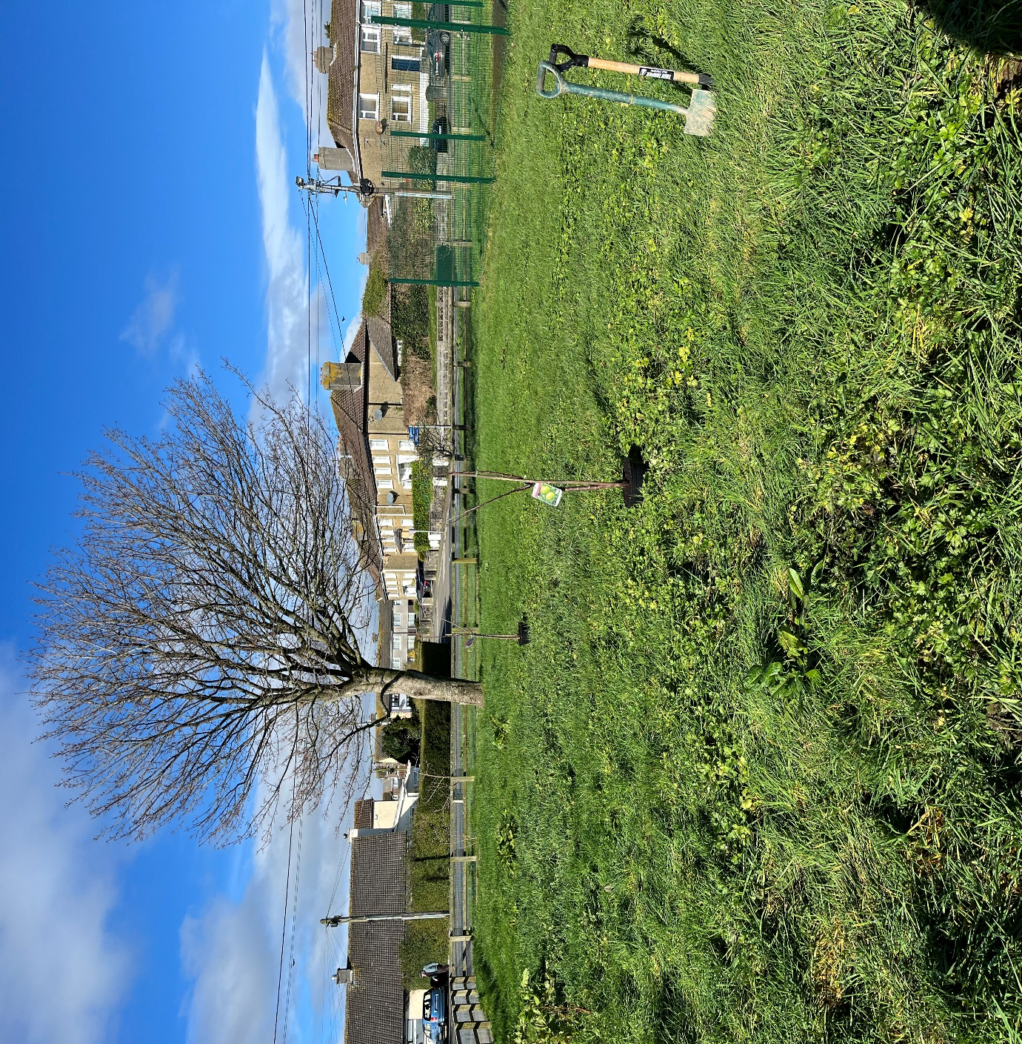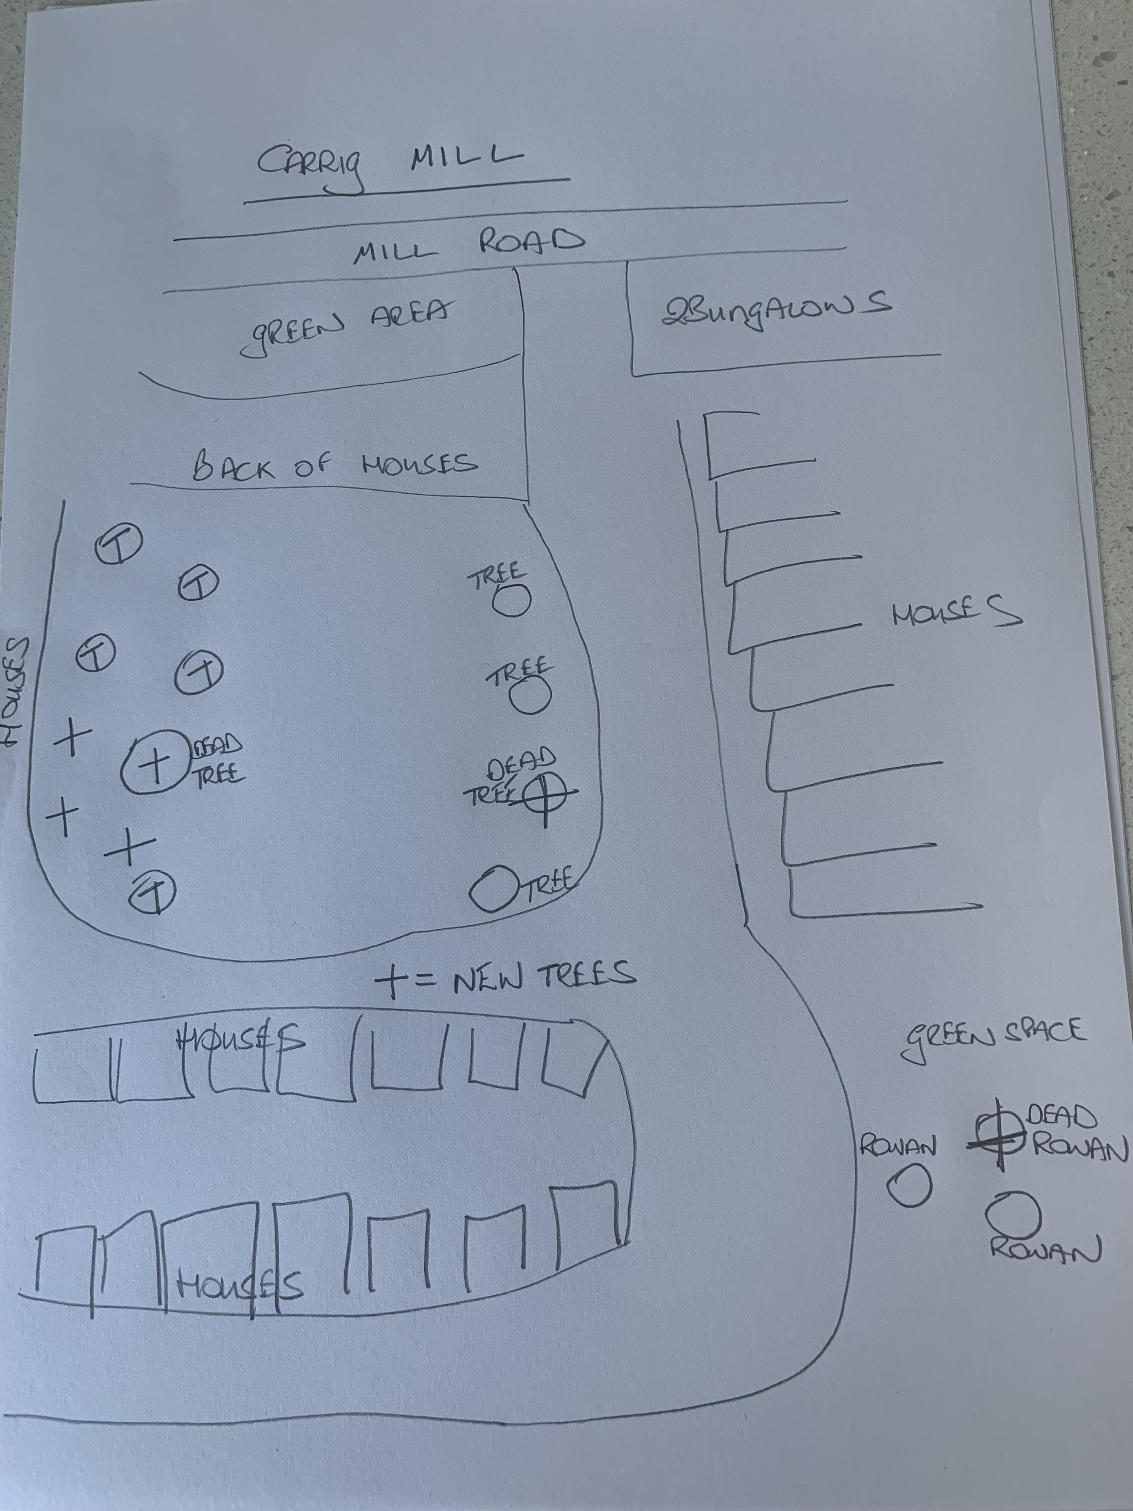
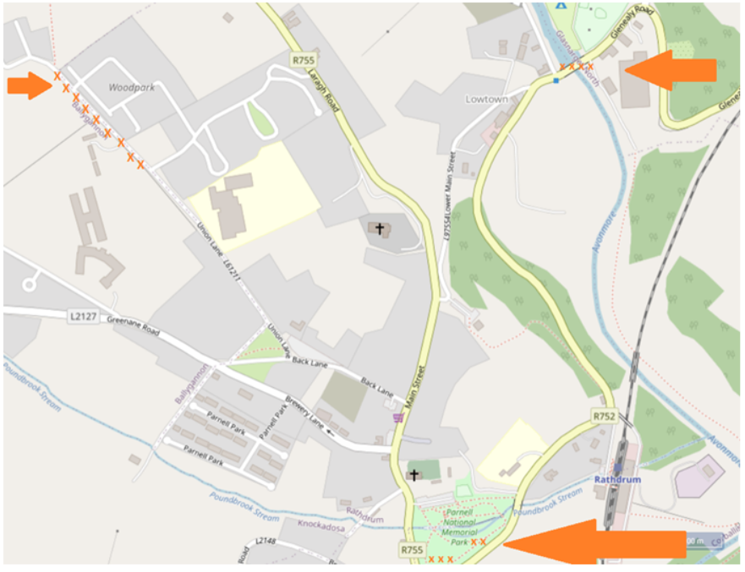

Some useful Resources

The following list of trees will be considered for grant being species or cultivars which are either native or suitable for attracting native pollinators.

Common Name | Latin name | Height (max) | Suitable for public open spaces | Suitable for streets and confined spaces | Suitable for tubs, containers, raised beds etc. | Guide to planting: see key below
Alder | Alnus Glutinosa | 22m | Yes | No | Yes | ADPS
Alder buckthorn | Frangula alnus | 6m | Yes | No | Yes | D
Apple cultivars | Malus Spp | 5m | Yes | Yes | Yes | AI
Arbutus (Strawberry tree) | Arbutus unedo | 8m | Yes | No | Yes | Not frost hardy
Aspen | Populas tremula | 24m | Yes | No | No | DPSV Not close to  Buildings or any  services
Beech | Fagus sylvatica | 50m | Yes | No | No | AHI
Bird Cherry | Prunus padus | 16m | Yes | No | No | AIP
Callery Pear | Pyrus calleryana chanticleer | 12m | Yes | Yes | No | AI
Crab apple | Malus sylvestris | 6m | Yes | No | No | AHIP
Downy birch | Betula pubescens | 18m | Yes | Yes | Yes | ADIP
Hawthorn | Crataegus monogyna | 9m | Yes | Yes | Yes | AHIPS
Hazel | Corylus avellana | 6m | Yes | No | No | AHS
Holly | Ilex aquifolium | 15m | Yes | Yes | Yes | AHPS
Horse Chestnut | Aesculus hippocastanum | 40m | Yes | No | No | AIP
Indian Bean Tree | Catalpa bignonioides | 12m | Yes | No | No | AI
Juneberry Tree | Amelanchier x grandiflora | 8m | Yes | Yes | No | I
Pear cultivars | Pyrus spp | 8m | Yes | No | Yes | AI
Pillar Crab | Malus tschonoskii | 12m | Yes | Yes | Yes | AIS
Plum | Prunus domestica | 5m | Yes | No | No | AI
Pedunculate Oak | Quercus robur | 30m | Yes | No | No | AI only suitable  for large spaces
Rowan or Mountain Ash | Sorbus aucaparia | 9m | Yes | Yes | Yes | ADHIP
Scots pine | Pinus sylvestris | 24m | Yes | No | No | AI
Sessile Oak | Quercus petraea | 30m | Yes | No | No | AI only suitable  for large spaces
Silver birch | Betula pendula | 18m | Yes | Yes | Yes | ADIP
Sloe, blackthorn | Prunus spinosa | 3m | Yes | No | No | AHPV
Spindle | Euonymous europaeus | 7.5m | Yes | No | No | H
Tai Haku Cherry | Prunus serrulata | 8m | Yes | No | No | AIP
Lime Tree | Tillia spp | Up to 50m | Yes | Yes ⃰2 | No | AIS
Whitebeam spp. | Sorbus aria | 12m | Yes | Yes | Yes | IPS
Wild cherry | Prunus avium | 15m | Yes | Yes | Yes | AHI
Willow spp. | Salix spp. | 6m | Some | No | No | V Not suitable  near buildings  or services
Wych elm | Ulmus Glabra | 30m | Yes | No | No | PS
Yew | Taxus baccata | 14m | Yes | Yes | Yes | AIPS

A – Grows in a wide variety of soils, C – Climber, H – Suitable for hedging, I – Suitable as an individual tree,
D – Tolerates or prefers damp conditions, P – Tolerates smoke or pollution, S – Tolerates shade, V – Invasive
* – Tolerates dry conditions

⃰2 There are a wide variety of Lime tree species and cultivars They range considerably in size and suitability for planting. Some are prone to aphid attack which can leave sticky residues on cars. Seek good advice from a horticulturist before choosing a cultivar of Lime.

The following species will be considered for the planting of mixed native hedging:

  - Blackthorn Prunus spinosa
  - Hawthorn Crataegus monogyna
  - Hazel Corylus avellana
  - Holly Ilex aquifolium
  - Guelder Rose Viburnum opulus
  - Spindle Euonymus europaeus
  - Dog Rose Rosa canina, or Sweet Briar Rosa rubiginosa
  - Wild Privet Ligustrum vulgare

Tree Council of Ireland
- How to Plant a Tree | Tree Council
- Right Tree Right Place | Tree Council
- https://youtu.be/eGRlKsNMXYM Tree Establishment & Tree Survival

